

root@cyberster:~$ whoami
> hanzallah — soc_intern
Week
06
Insider Threat Simulation & Incident Response
// candidate Hanzallah
// program Cyberster — Cybersecurity Internship (Batch 2)
// tutor Abdullah Zia
[ STATUS: TASKS COMPLETE — READY FOR REVIEW ]
Week 6: Insider Threat Simulation & Incident Response
Phase One Capstone — Cyberster Blue Team Internship | SOC Operations & SIEM Foundations
// 00 OVERVIEW & SCOPE
This report documents a full attack-and-defend simulation of an insider threat scenario, executed end-to-end on the internship lab environment. The scenario involved staging, encoding, exfiltrating, and attempting to destroy evidence of a confidential client data theft on a Windows endpoint monitored by Wazuh. Both the offensive execution and the defensive investigation were carried out and documented as part of this exercise.
The environment consists of a Windows 10 endpoint (Wazuh agent), a Kali Linux attacker VM, and an Ubuntu Server running the Wazuh Manager, all on a shared Host-Only lab network. File Integrity Monitoring (syscheck) was configured on a dedicated staging directory (C:\Espionage) prior to attack execution to ensure full log coverage.
// 01 EXECUTIVE SUMMARY

On the date of this exercise, a simulated insider — an employee with legitimate access to a Windows workstation — accessed and copied a confidential client database file to a staging location on their local machine. The file contained client account and password information.
The employee then converted the file into an encoded format (Base64) to disguise its contents from casual inspection, and transmitted the encoded data over the internal network to a separate machine using a web request rather than a standard file-transfer method. Following the transfer, the employee deleted the original and encoded files from their workstation in an attempt to remove evidence of the activity.
The security monitoring system (Wazuh) in place on the workstation detected and logged each of these actions in real time, including the file creation, the encoding step, and the deletion — because File Integrity Monitoring records file system events as they happen, deletion after the fact does not remove the historical record. The exfiltrated data was subsequently recovered and decoded from network capture, confirming the exact contents of the stolen file.
In response, a new detection rule was written and deployed to flag this specific attack pattern — creation of an encoded file in the staging directory — as a high-priority alert going forward. This report documents the full timeline, the evidence collected, the technical analysis, and the response and recovery measures appropriate to an incident of this type in a production environment.

// 02 DETECTION & ANALYSIS
$ Attack Timeline & MITRE ATT&CK Mapping
The table below maps each attacker action to the corresponding log evidence and MITRE ATT&CK technique.
Step | Time / Sequence | Attacker Action | Log Evidence | MITRE ATT&CK
1 | T+0:00 | Staged confidential file in C:\Espionage | Wazuh rule 550 (FIM creation) — Client_Database.txt | T1074 — Data Staged
2 | T+0:01 | Encoded file to Base64 via certutil.exe | Wazuh rule 550 (FIM creation) — system_cache.b64 | T1027 — Obfuscated Files or Information
3 | T+0:02 | Exfiltrated encoded payload via HTTP POST to port 8080 | Kali nc listener capture; network traffic to attacker-controlled endpoint | T1048 — Exfiltration Over Alternative Protocol
4 | T+0:03 | Deleted both files from C:\Espionage | Wazuh rule 553 (FIM deletion) | T1070 — Indicator Removal
$ Technique Detail
- T1074 — Data Staged: the attacker created Client_Database.txt in C:\Espionage prior to exfiltration, consolidating the target data in a single location on the endpoint.
- T1027 — Obfuscated Files or Information: certutil.exe was used to encode the file as Base64, disguising its content and file signature from casual inspection and simple content-based detection.
- T1048 — Exfiltration Over Alternative Protocol: the encoded payload was pushed via HTTP POST to a listener on port 8080, using a web request rather than a standard file-transfer or exfiltration channel.
- T1070 — Indicator Removal: the attacker deleted all files from C:\Espionage in an attempt to destroy forensic evidence of the activity.

$ Evidence — FIM Deletion Alert & FIM Creation Alerts

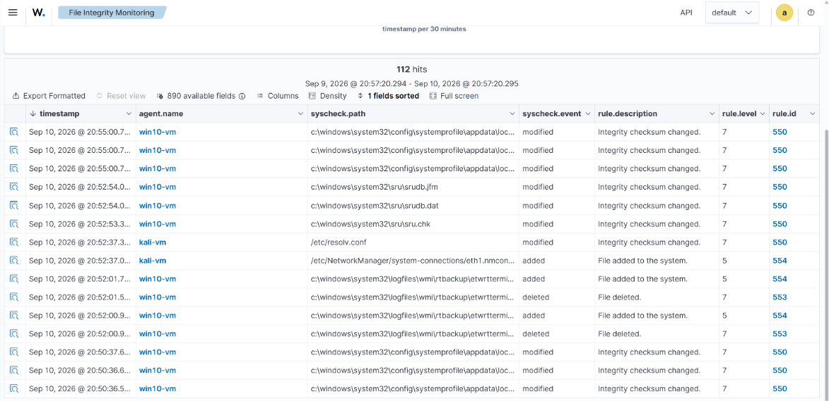

$ Evidence 3 — Decoded Exfiltrated Data
The Base64 payload captured at the Kali nc listener during exfiltration was decoded using CyberChef's From Base64 recipe, confirming the exact content of the stolen file.
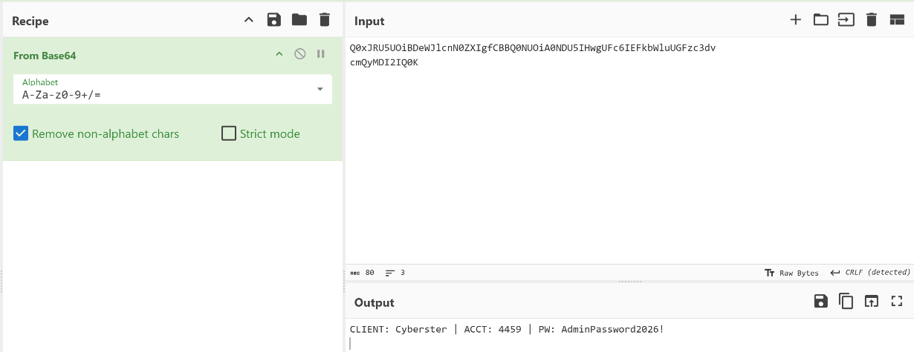
Fig. 3 — CyberChef interface showing the Base64 input string and the decoded plaintext client data.

// 03 CONTAINMENT, ERADICATION & RECOVERY
$ Containment
The compromised user account should be disabled immediately upon confirmation of unauthorized data staging and exfiltration activity, rather than merely having its password reset — a rogue insider retains knowledge of the environment even after credential rotation. Active sessions for the account should be forcibly terminated across all endpoints, and the account should be removed from any groups granting access to shared drives, databases, or client-record systems pending investigation. The affected workstation should be isolated from the network at the switch or firewall level (not merely disconnected by the user) to prevent further outbound transfers while forensic imaging is performed.

$ Eradication
A full forensic image of the affected endpoint should be taken before any remediation to preserve evidence for potential legal or HR action. The investigation should verify that no additional persistence mechanisms were established — scheduled tasks, registry run keys, unauthorized local accounts, or unfamiliar services — since an insider with legitimate access may have taken preparatory steps beyond the single exfiltration event observed. Outbound firewall logs and DNS query history for the endpoint should be reviewed for any additional connections to the same or related external/internal IP addresses beyond the single Kali listener observed in this simulation. Any credentials known to the employee that grant access to other systems (shared service accounts, database credentials, VPN access) should be rotated as a precaution.

$ Recovery
The workstation should be rebuilt from a known-good image rather than cleaned in place, given the endpoint was under direct control of a malicious insider with local administrative access. The user's account, if retained pending investigation outcome, should be re-enabled only with reduced privileges and enhanced logging, and only after HR and legal review is complete. Confirmation that the environment is safe to return to normal operation should include a verification pass of FIM alert history for the rebuilt endpoint over a monitoring period, confirmation that the custom detection rule (see Section 4) is active and has been validated against a live test event, and a review with the data owner to confirm the scope of affected client records for breach notification purposes.

// 04 POST-INCIDENT ACTIVITY
$ Custom Detection Rule
The following Wazuh rule was written and deployed to local_rules.xml to detect this attack pattern going forward:
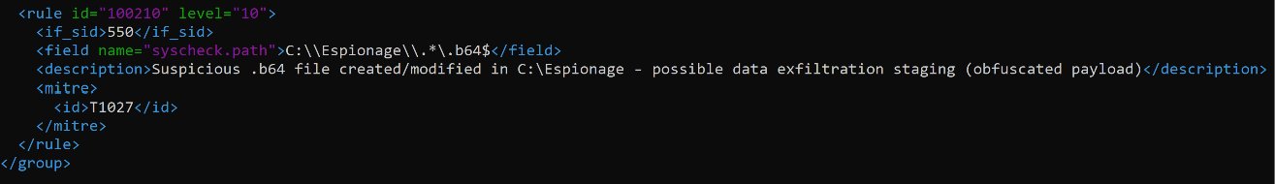
This rule fires as a child of the base FIM checksum-change rule (550), narrowing the match to any file ending in .b64 created or modified within C:\Espionage. It is set to Level 10 — a real-time notification threshold in production Wazuh — because the combination of an encoded file extension and a sensitive staging directory has no legitimate business justification in this environment and warrants immediate analyst attention rather than passive logging. The rule is mapped to MITRE technique T1027 (Obfuscated Files or Information), tying the alert directly to the attacker behavior it is designed to catch.
Prior to this rule's deployment, an event of this type would have generated only a generic Level 5–7 FIM checksum-change alert indistinguishable from routine file activity elsewhere on the endpoint. This rule closes that gap by giving encoded-payload staging in a sensitive directory its own dedicated, high-priority signature.
$ Lessons Learned
- Visibility into C:\Espionage depended entirely on the syscheck directory being manually added to ossec.conf beforehand — a monitored-directory scope that is not automatic represents a real blind spot for any staging location an insider chooses that isn't already covered by default FIM rules.
- The default Wazuh ruleset does not distinguish between routine file modification and the creation of an encoded (.b64) file in a sensitive path — encoding-based obfuscation of exfiltrated data would have passed as a standard, low-priority FIM event without the custom rule added in this exercise.
- Network-layer visibility (e.g., an IDS/IPS signature for outbound HTTP POST traffic to non-standard internal listener ports) would have provided a second, independent detection layer for the exfiltration step (T1048) itself, rather than relying solely on endpoint FIM to reconstruct that the transfer occurred.
- Going forward, staging directories used for sensitive data handling should be identified proactively and added to FIM scope as part of standard endpoint provisioning, rather than being added reactively after a specific investigation need arises.

